 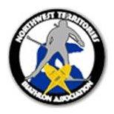

**Welcome to the AWG 2024 Biathlon Trials at the Hay River Ski Club!**

From Wednesday, November 22nd through to Sunday, November 26th, biathletes from across the Northwest Territories will be in Hay River for a weekend of competition as we select Team NWT for the 2024 AWG’s!

The Hay River Ski Club (hayriverskiclub.com) extends a warm welcome to athletes and coaches. We will do our best to make this a terrific sporting experience for one and all!

**Policies** – Athlete Selection, Cold Weather, Coach Selection, Dispute Resolution

Available online at https://sites.google.com/view/northwest-territories-biathlon/contact-us

AWG Technical Packages can be viewed online at: <https://arcticwintergames.net/Hosting-and-Sport-Technical-Info/Sport-Technical-Packages/Biathlon-Ski-$26-Snowshoe>

**NWT Biathlon Registration** - For purposes of insurance, all athletes and coaches must be registered with NWT Biathlon and Biathlon Canada. You will not be permitted to participate without coverage. To register, follow the link [Biathlon Canada - Membership](https://www.biathloncanada.ca/membership)

For the purposes of the AWG Trials only, athletes can register as a ‘Recreational Athlete’ for a $10 fee. Athletes that qualify for the AWG’s will have to register as a Junior ($40 – Under age 15, born in 2009 or later) or Senior ($80 – Age 15+, born in 2008 or prior) athlete in order to be eligible to compete.

**Race Format**

Wednesday Nov 22nd Travel Day

Thursday Nov 23rd Training Day

AM Out of Town Athletes Only

Lunch provided at the Ski Club for Out of Town Athletes/Coaches

PM All Athletes - Practice Session

Friday Nov 24th AM Optional Training

Lunch Provided by HRSC

PM Individual 1 PM Sight In, 2 PM Race

Medal Presentations to Follow

U 18 Snowshoe (5 km) Green-Pink-Pink-Pink-Purple PSPS

U 15 Snowshoe (3 km) Pink-Pink-Purple-Purple PPP

U 18 Ski (7.5 km) Orange – Orange – Orange – Green – Pink PSPS

U 15 Ski (5 km) Orange – Green – Pink – Pink PPP

Saturday, Nov 25th AM Sprint 10 AM Sight In, 11 AM Race

Lunch Provided by HRSC, Medal Presentations to Follow

U 18 Snowshoe (3 km) Green – Pink – Purple PS

U 15 Snowshoe (2 km) Pink – Purple – Purple PP

U 18 Ski (6 km) Blue – Orange – Orange PS

U 15 Ski (4 km) Green – Green – Pink PP

PM Introduction of Team NWT

Team NWT Team Meeting

Sunday Nov 26th Travel Day

Combined results of the two races will determine Team NWT. The top two athletes in each category are selected to the Team; the third place athlete is considered to be the Alternate.

If weather allows for only one race, the team will be selected on that basis.

The long range weather forecast is favorable at this time. If cold weather precludes outdoor races, the team will be selected indoors (PA School) using air rifles (running and shooting). Athletes will also be required to briefly demonstrate ski and snowshoe ability outdoors, as well as rifle proficiency and safety.

* Set up and practice would take place on Friday afternoon, Nov 24th. The Individual would take place during the evening of Friday, Nov 24th and the Sprint on the morning of Saturday, Nov 25th.
* In the event that we are indoors, please pack your indoor running shoes and appropriate clothing for running indoors.

**Equipment**

Athletes are responsible for all race equipment including snowshoes, bindings and moccasins, skis, poles and boots, winter outdoor clothing, clothing for cold weather indoor event (running gear and shoes).

Athletes without suitable outdoor clothing (head gear, gloves suitable for shooting, neck-warmers, winter jackets and pants) will not be allowed to participate.

A limited number of rifles will be available to Out of Town athletes. Ammunition will be provided to all competitors. Athletes qualifying for Team NWT will be issued with a rifle to take home, provided the Coach/Chaperone possesses a valid FAC. These rifles are then returned to the HRSC after the Games.

Any athlete deemed to be unsafe in the handling of firearms will automatically be disqualified.

**Accommodations, Meals & Transportation**

Thanks to support from **Greenway Accommodations**, Out of Town athletes and coaches will be staying in accommodations as provided by them. No bedding is required, but you should bring your own towel . Please express your appreciation to Jane Groenewegen for her support of the NWT Trials!

**Aurora Ford** in Hay River has donated the use of three vehicles for the Trials. Coaches (Belinda, Holly & Doug) will be responsible for transportation to and from the Ski Club and into Town for dinners. Please express your appreciation to Steve Campbell for his support of the NWT Trials!

Continental Breakfast items will be provided at the accommodations, as coordinated by coaches/chaperones.

Lunch will be provided at the Ski Club.

Dinner is the responsibility of each athlete (enjoy our restaurants!)

Athletes and chaperones may choose to reserve private accommodations with friends or hotel accommodations. Please advise if this is the case. All costs associated with private accommodations are the responsibility of the athlete and chaperone.

**Coaching**

The Head Coach has been selected by NWT Biathlon for AWG 2024.

Doug Lockhart Yellowknife

The remainder of the Team NWT Coaching Staff will be selected at the AWG Trials in Hay River.

**Schedule**

**Wed, Nov 22nd**

TBD Arrival to Hay River by Charter (Sport North)

All sporting equipment and rifles will be transported to the Garage at the Ski Club (Chuck). Three rental vehicles will proceed with luggage to the Greenway accommodations (Belinda, Holly and Doug L)

**Thurs, Nov 23rd**

Training – Rifle Fitting (Out of Town athletes), Range Procedure, Trails Familiarization, Combo work

Introductions, Jury Selection, Complete NWT Biathlon Information Forms

**Friday, Nov 24th**

Individual race (ski / snowshoe)

**Sat, Nov 25th**

Sprint race (ski / snowshoe)

Combine race results (Chief of Competition) and Selection of Team NWT

**Sun, Nov 26th**

TBD Depart accommodation and Hay River via Charter (Sport North)

**Contacts**

Doug Swallow Chief of Competition [dougswa@gmail.com](mailto:dougswa@gmail.com) 780-910-9175

Chuck Lirette HR Ski Club [clirette@northwestel.net](mailto:clirette@northwestel.net) 867-875-7849

Doug Lockhart Head Coach [biathlonnwt@gmail.com](mailto:biathlonnwt@gmail.com) 867-447-1477

**Key Volunteers** – They’ve worked hard and really appreciate a ‘**big**’ thank you!

Doug Swallow – Chief of Competition, HRSC

Kandace Groenewegen – Breakfast and Lunches, HRSC

Chuck Lirette – Chief of Range, Set-up, HRSC

Belinda Whitford – Chief of Timing & Results, YKSC

Dorothy Lirette – Head of Officials, HRSC

Doug Lockhart – Team NWT Biathlon Head Coach

Kandace Groenewegen – President, NWT Biathlon

Enjoy your stay in Hay River! If you have any questions, contact your local coach or Chuck Lirette at the Hay River Ski Club.

See you soon! 😊

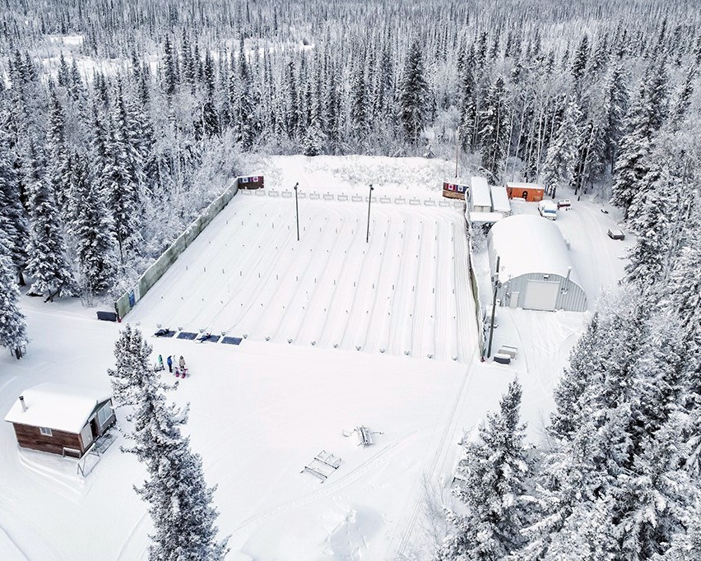

*Hay River Ski Club – Biathlon Range*